Programming Exercise 7:

Regularized Linear Regression and Bias v.s.Variance

In this exercise, you will implement regularized linear regression and use it to study models with different bias-variance properties.

1 Regularized Linear Regression

In the first half of the exercise, you will implement regularized linear regression to predict the amount of water owing out of a dam using the change of water level in a reservoir. In the next half, you will go through some diagnostics of debugging learning algorithms and examine the effects of bias v.s. variance.

1.1 Visualizing the dataset

We will begin by visualizing the dataset containing historical records on the change in the water level, x, and the amount of water owing out of the dam, y.

This dataset is divided into three parts:

• A training set that your model will learn on: X, y

• A cross validation set for determining the regularization parameter: Xval, yval

• A test set for evaluating performance. These are \unseen" examples which your model did not see during training: Xtest, ytest

The next step plot the training data (Figure 1). In the following parts, you will implement linear regression and use that to fit a straight line to the data and plot learning curves. Following that, you will implement polynomial regression to find a better fit to the data.

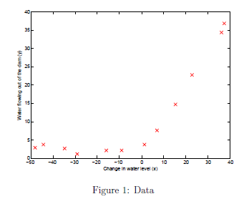

Figure 1: Data

To open .mat file in python:

from scipy.io import loadmat

data=loadmat('ex7data1') #load of data

1.2 Regularized linear regression cost function

Recall that regularized linear regression has the following cost function:

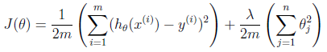

where lambda is a regularization parameter which controls the degree of regularization (thus, help preventing overfitting). The regularization term puts a penalty on the overal cost J. As the magnitudes of the model parameters  increase, the penalty increases as well. Note that you should not regularize the  term.

Your task is to write a function to calculate the regularized linear regression cost function. Vectorize your code and avoid writing loops.

When you are finished, run your cost function using theta initialized at [1; 1]. You should expect to see an output of 303.993.

1.3 Regularized linear regression gradient

Correspondingly, the partial derivative of regularized linear regression's cost

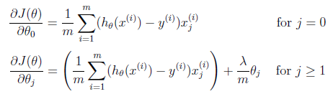

In Calculate the gradient, returning it in the variable grad. When you are finished, the next part

run your gradient function using theta initialized at [1; 1]. You should expect to see a gradient of [-15.30; 598.250].

1.4 Fitting linear regression

Once your cost function and gradient are working correctly, the next part to compute the optimal values for of .

In this part, we set regularization parameter lambda to zero. Because our current implementation of linear regression is trying to fit a 2-dimensional , regularization will not be incredibly helpful for a  of such low dimension. In the later parts of the exercise, you will be using polynomial regression with regularization.

Finally, your script should also plot the best fit line, resulting in an image similar to Figure 2.

The best fit line tells us that the model is not a good fit to the data because the data has a non-linear pattern. While visualizing the best fit as shown is one possible way to debug your learning

algorithm, it is not always easy to visualize the data and model. In the next section, you will implement a function to generate learning curves that can help you debug your learning algorithm even if it is not easy to visualize the data.

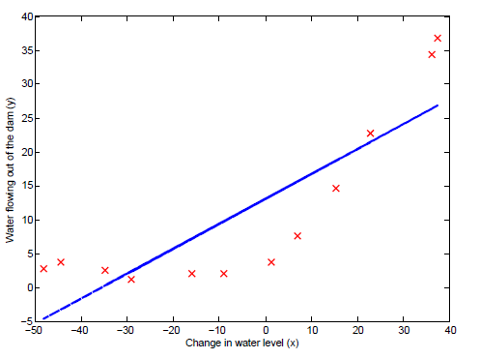

Figure 2: Linear Fit

2 Bias-variance

An important concept in machine learning is the bias-variance tradeoff. Models with high bias are not complex enough for the data and tend to underfit, while models with high variance overfit to the training data.

In this part of the exercise, you will plot training and test errors on a learning curve to diagnose bias-variance problems.

2.1 Learning curves

You will now implement code to generate the learning curves that will be useful in debugging learning algorithms. Recall that a learning curve plots training and cross validation error as a function of training set size. Your job is to return a vector of errors for the training set and cross validation set.

To plot the learning curve, we need training and cross validation set error for different training set sizes. To obtain different training set sizes, you should use different subsets of the original training set X. Specifically, for a training set size of i, you should use the first i examples (i.e., X(1:i,:) and y(1:i)).

You can use the function to find the  parameters.

After learning the  parameters, you should compute the error on the training and cross validation sets. Recall that the training error for a dataset is defined as

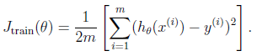

In particular, note that the training error does not include the regularization term. One way to compute the training error is to use your existing cost function and set lambda to 0 only when using it to compute the training error and cross validation error. When you are computing the training set error, make sure you compute it on the training subset (i.e., X(1:n,:) and y(1:n))

(instead of the entire training set). However, for the cross validation error, you should compute it over the entire cross validation set. You should store the computed errors in the vectors error train and error val.

When you are finished, print the learning curves and produce a plot similar to Figure 3.

In Figure 3, you can observe that both the train error and cross validation error are high when the number of training examples is increased. This reflects a high bias problem in the model { the linear regression model is too simple and is unable to fit our dataset well. In the next section, you will implement polynomial regression to fit a better model for this dataset. 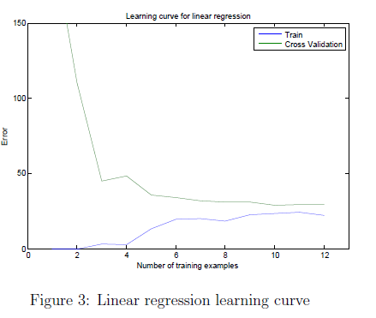

3 Polynomial regression

The problem with our linear model was that it was too simple for the data and resulted in underftting (high bias). In this part of the exercise, you will address this problem by adding more features.

For use polynomial regression, our hypothesis has the form:

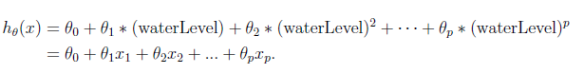

Notice that by defining x1 = (waterLevel); x2 = (waterLevel)2; : : : ; xp = (waterLevel)p, we obtain a linear regression model where the features are the various powers of the original value (waterLevel).

Now, you will add more features using the higher powers of the existing feature x in the dataset. Your task in this part is to complete the code in so that the function maps the original training set X of size mx1 into its higher powers. Specifically, when a training set X of size mx1 is passed into the function, the function should return a mxp matrix X poly, where column 1 holds the original values of X, column 2 holds the values of X.^2, column 3 holds the values of X.^3, and so on. Note that you don't have to account for the zero-eth power in this function.

Now you have a function that will map features to a higher dimension, and apply it to the training set, the test set, and the cross validation set (which you haven't used yet).

3.1 Learning Polynomial Regression

After you have completed poly Features, proceed to train polynomial regression using your linear regression cost function.

Keep in mind that even though we have polynomial terms in our feature vector, we are still solving a linear regression optimization problem. The polynomial terms have simply turned into features that we can use for linear regression. We are using the same cost function and gradient that you wrote for the earlier part of this exercise.

For this part of the exercise, you will be using a polynomial of degree 8.

It turns out that if we run the training directly on the projected data, will not work well as the features would be badly scaled (e.g., an example with x = 40 will now have a feature x8 = 408 = 6:5 _ 1012). Therefore, you will need to use feature normalization.

Before learning the parameters  for the polynomial regression, first normalize the features of the training set.

After learning the parameters, you should see two plots (Figure 4,5) generated for polynomial regression with lambda = 0.

From Figure 4, you should see that the polynomial fit is able to follow the data points very well - thus, obtaining a low training error. However, the polynomial fit is very complex and even drops off at the extremes. This is an indicator that the polynomial regression model is overfitting the training data and will not generalize well.

To better understand the problems with the unregularized ( = 0) model, you can see that the learning curve (Figure 5) shows the same effect where the low training error is low, but the cross validation error is high. There is a gap between the training and cross validation errors, indicating a high variance problem.

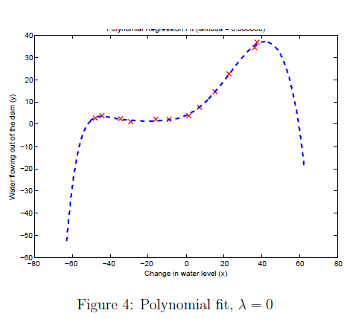

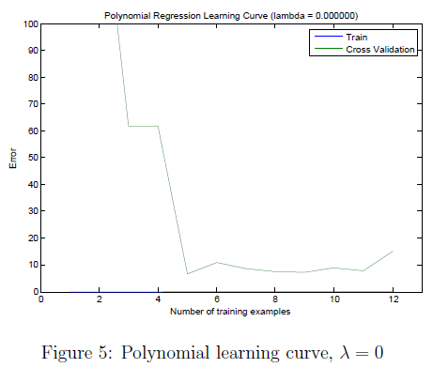

One way to combat the overfitting (high-variance) problem is to add regularization to the model. In the next section, you will get to try different lambda parameters to see how regularization can lead to a better model.

3.2 Adjusting the regularization parameter

In this section, you will get to observe how the regularization parameter affects the bias-variance of regularized polynomial regression. You should now modify the lambda parameter and try lambda = 1; 100. For each of these values, the script should generate a polynomial fit to the data and also a learning curve.

For lambda = 1, you should see a polynomial fit that follows the data trend well (Figure 6) and a learning curve (Figure 7) showing that both the cross validation and training error converge to a relatively low value. This shows the lambda = 1 regularized polynomial regression model does not have the high-bias or high-variance problems. In effect, it achieves a good trade-ff between bias and variance.

For lambda = 100, you should see a polynomial fit (Figure 8) that does not follow the data well. In this case, there is too much regularization and the model is unable to fit the training data.

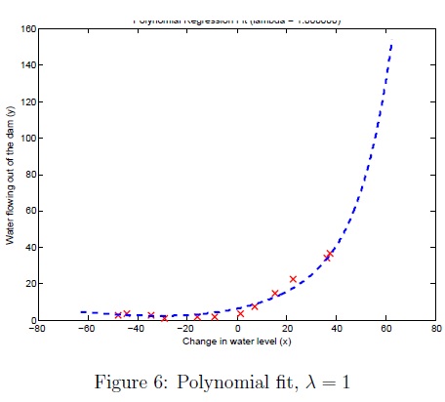

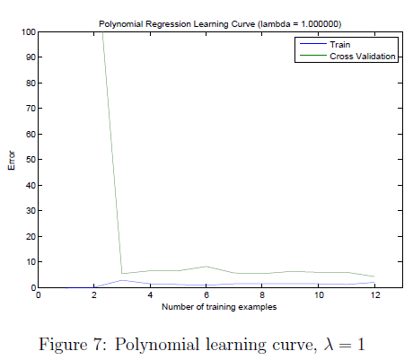

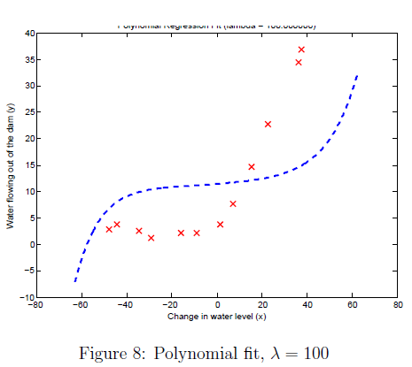

3.3 Selecting  using a cross validation set

From the previous parts of the exercise, you observed that the value of  can significantly affect the results of regularized polynomial regression on the training and cross validation set. In particular, a model without regularization ( = 0) fits the training set well, but does not generalize. Conversely, a model with too much regularization ( = 100) does not fit the training set and testing set well. A good choice of  (e.g., _ = 1) can provide a good fit to the data.

In this section, you will implement an automated method to select the  parameter. Concretely, you will use a cross validation set to evaluate how good each  value is. After selecting the best  value using the cross validation set, we can then evaluate the model on the test set to estimate how well the model will perform on actual unseen data.

Your task is to complete the code. Specifically, you should use the train LinearReg function to train the model using different values of  and compute the training error and cross validation error.

You should try in the following range: f0; 0:001; 0:003; 0:01; 0:03; 0:1; 0:3; 1; 3; 10g.

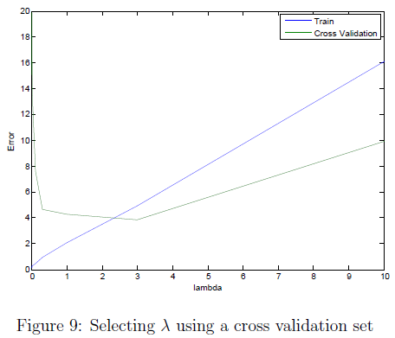

Figure 9: Selecting _ using a cross validation set

After you have completed the code, the next part of task will run your function can plot a cross validation curve of error v.s.  that allows you select which  parameter to use. You should see a plot similar to Figure 9. In this figure, we can see that the best value of  is around 3. Due to randomness in the training and validation splits of the dataset, the cross validation error can sometimes be lower than the training error.

3.4 Computing test set error

In the previous part of the exercise, you implemented code to compute the cross validation error for various values of the regularization parameter .

However, to get a better indication of the model's performance in the real world, it is important to evaluate the “final" model on a test set that was not used in any part of training (that is, it was neither used to select the  parameters, nor to learn the model parameters thetta).

For this optional (ungraded) exercise, you should compute the test error using the best value of  you found. In our cross validation, we obtained a test error of 3.8599 for  = 3.

3.5 Plotting learning curves with randomly selected examples

In practice, especially for small training sets, when you plot learning curves to debug your algorithms, it is often helpful to average across multiple sets of randomly selected examples to determine the training error and cross validation error.

Concretely, to determine the training error and cross validation error for i examples, you should first randomly select i examples from the training set and i examples from the cross validation set. You will then learn the parameters _ using the randomly chosen training set and evaluate the parameters

Thetta on the randomly chosen training set and cross validation set. The above steps should then be repeated multiple times (say 50) and the averaged error should be used to determine the training error and cross validation error for i examples.

For this exercise, you should implement the above strategy for computing the learning curves. For reference, Figure 10 shows the learning curve we obtained for polynomial regression with  = 0:01. Your figure may differ slightly due to the random selection of examples.

